**Short Circuit Duty**



**Javier Jesús Macossay-Hernández**

**EE443 – Introduction to Power Systems**

**University of Southern California**

**Professor Robert Castro**

**Objective**

In this problem, the short the fault duty and the reactance for each component will be calculated in a one-line diagram using the values calculated by the simulation in PowerWorld.

**Introduction**

We will use PowerWorld to simulate a fault on a bus in a system. Next, we will simplify the circuit into a one-line diagram of a system containing two parallel generators, three transformers, a transmission line, and a bus.

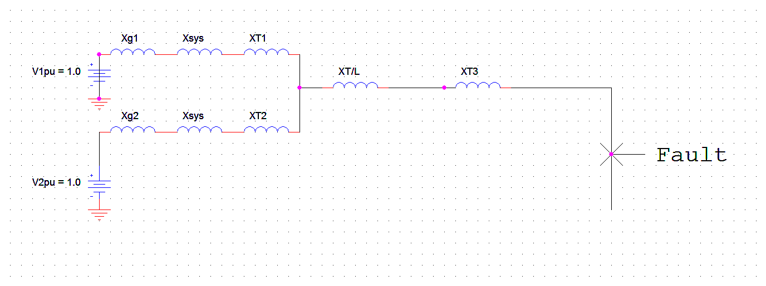

Figure 1: Reactance diagram showing the Xsys and fault

**Methods**

We will choose a bus for the location on the fault from Design Case 2. For this problem, we will use the bus called “PATTEN69,” which is found on the bottom area of the system. The selected bus in the system are shown in Figure 2 and Figure 3.

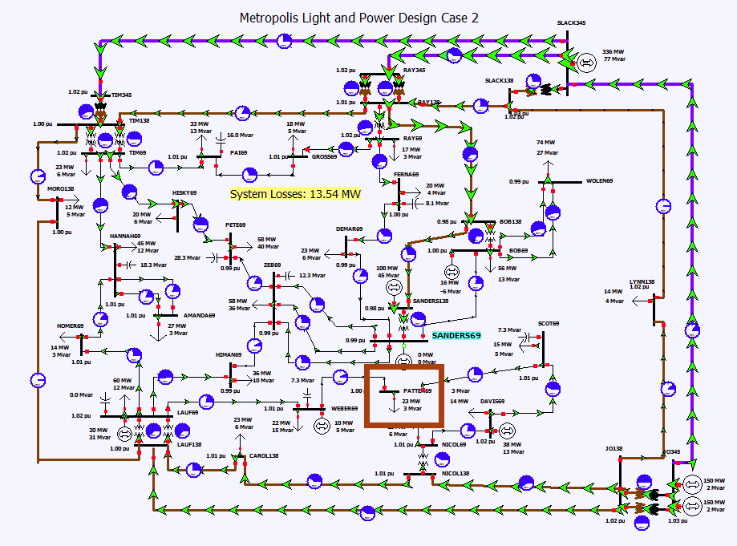

Figure 2: One-line diagram of Design Case 2

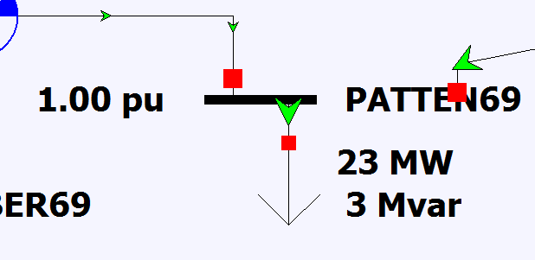

Figure 3: Zoom of bus “PATTEN69”

For the fault simulation at bus “PATTEN69,” we will right-click the bus and select “Fault…” and, as a result, it will show up a dialog menu for Fault Analysis. On the left menu, we will click the “Single Fault” menu, then click Bus Records. After double checking that the bus “PATTEN69” is already selected, we will click the “Calculate” button and PowerWorld will show the fault current in per unit and amperes. As seen in Figure 5 and Figure 6, the fault current is 8.848 pu and 7403.39 amps, respectively.

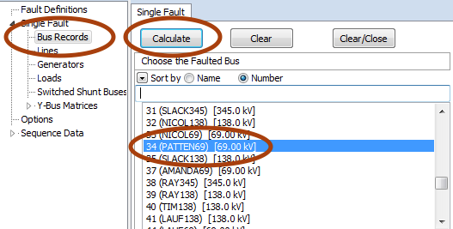

Figure 4: Procedure for Fault Analysis

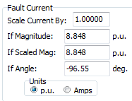

Figure 5: Fault Current in per unit

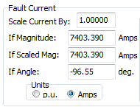

Figure 6: Fault Current in amperes

**Calculations**

With the fault current, we can find the total reactance of the system:

If = 1.0/Xtotal = 8.848 $→$ Xtotal = 0.113

Xtotal is the sum of all the reactance:

Xtotal = (XG1 + Xsys + XT1) || (XG2 + Xsys + XT2) + XT/L + XT3

Since we do not know the exact distribution of reactance and the value of the transformers, we will make some assumptions about how the reactance is distributed in the system and the voltage and apparent power of the transformers.

(XG1 + Xsys + XT1) || (XG2 + Xsys + XT2) = 0.8 Xtotal = j0.0904

(XG2 + Xsys + XT2) = 1.6 Xtotal = j0.1808

XG2 = Xsys = XT2 = j0.0603

XG1 = Xsys = XT1 = j0.0603

XT/L = 0.1 Xtotal = j0.0113

XT3 = 0.1 Xtotal = j0.0113

We will assume that the zones are separated by 90 kV/ 250 kV and 90 MVA transformers. In addition, the apparent power of the generator is 90 MVA and is rated in 90 kV. With this assumptions, we can find the zone voltages and impedances for each zones, but first I will calculate the base current for zone 3. We will need to find the base current for zone 3 because the fault occurs in zone 3. We will use the base current to calculate the base MVA, apparent power, for the system.

IB3 = = = 836.73 amperes

MVAB = VIB3 = (90 kV) (836.73 A) = 130 MVA

VB1 = (250) $\left(\frac{90}{250}\right)$ = 90 kV

VB2 = (90) $\left(\frac{250}{90}\right)$ = 250 kV

VB3 = (250) $\left(\frac{90}{250}\right)$ = 90 kV

ZB1 = = 62.31 Ω

ZB2 = = 480.77 Ω

ZB3 = = 62.31 Ω

Using the values calculated before, we will find the short circuit duty for the system:

MVAduty = VISC = (90 kV) (7403.39 A) = 1,154 MVA

Now, we will have to find the old reactance of the components because the apparent power, MVA, of the transformers is not equal to the base apparent power. The

XG1, old = XG1, new = j0.0603 ${\left(\frac{90}{90}\right)}^{2}(\frac{90}{130})$ = j0.041746 pu

XT1, old = XT1, new = j0.0603 ${\left(\frac{250}{250}\right)}^{2}(\frac{90}{130})$ = j0.041746 pu

XG1 = XT1 = XG2 = Xsys = XT2 = j0.041746 pu

XT3, old = XT3, new = j0.0113 ${\left(\frac{90}{90}\right)}^{2}(\frac{90}{130})$ = j0.007823 pu

XT/L = (XT/L pu) (ZB2) = (j0.0113) (480.77 Ω) = j5.4327Ω

Finally, we will assume the transmission line has an impedance of 0.6Ω/mile because we want to find the length of the transmission line.

$\frac{5.4327 ohms}{0.6 ohms/mile}$**=** 9.0545 miles $≈$ 9.055 miles

**Results**

Since we have calculated all the parameters, we will create a single line diagram.

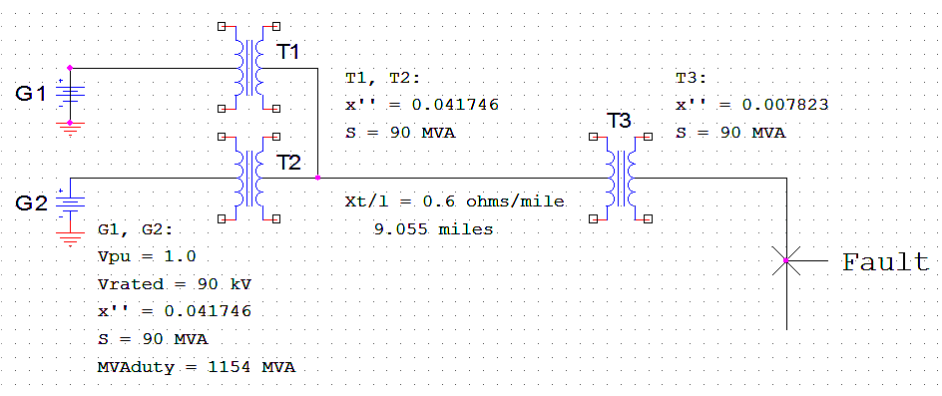

**Discussion**

In this problem, we used the concepts of short circuit duty, practiced material learned in class, and made some assumptions to calculated the reactance of the different components of the system. After using the PowerWorld simulation to get the values of the fault current in amperes and per unit, we were able to to create the single line diagram with all the components initially shown in the reactance diagram.